Game Design Document

Fill up the following document

1. Write the title of your project.

Destroy The Summarine

1. What is the goal of the game?

To destroy the opponent Summarine

1. Write a brief story of your game.

To protect our country from the underwater intuders

1. Which are the playing characters of this game?

* Playing characters are the ones who respond to the user based on the input from the user.
* Cars, monkeys, dinos, wizards, etc., are the playing characters in the game.

|  |  |  |
| --- | --- | --- |
| Number | Character Name | What can this character do? |
| 1 | Summarine 1 | Has to destroy the opponen’ s summarine. |
| 2 |  |  |
| 3 |  |  |
| 4 |  |  |
| 5 |  |  |
| 6 |  |  |
| 7 |  |  |
| 8 |  |  |

1. Which are the Non-Playing Characters of this game?

* Non-Playing characters are the ones that don't have an action or behavior when the user interacts with the game.
* Hurdles, stones, bananas, coins, etc., are non-playing characters in the game.

|  |  |  |
| --- | --- | --- |
| Number | Character Name | What can this character do? |
| 1 | Summarine 2 | Has to destroy the summarine 1 |
| 2 | Summarine 3 | Has to destroy the summarine 1 |
| 3 |  |  |
| 4 |  |  |
| 5 |  |  |
| 6 |  |  |
| 7 |  |  |
| 8 |  |  |

Draw your imagination of this game. What does this game look like?

* Draw the game either on your computer or on paper.
* Add images of the game scenes to show each of the playing and non-playing characters at least once.

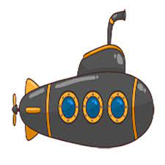 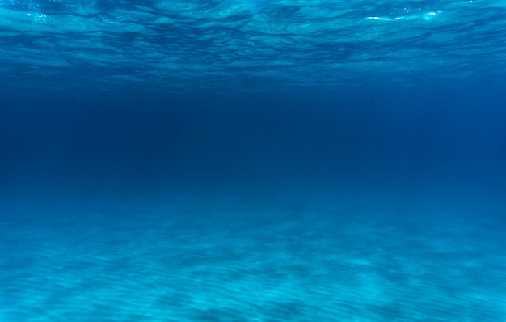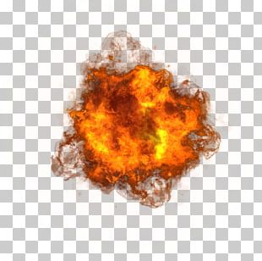

How do you plan to make your game engaging?

To make a Game engaging I will be adding game adaptivity by increasing the difficulty level based on scoring.